SANATANA DHARMA COLLEGE, ALAPPUZHA
DEPARTMENT OF MATHEMATICS
Mathematics internal examination for s2 B.sc Chemistry
Time 1.5 hrs Max marks:40

 |  | Outcome based internal evaluation blueprint-2022-23
 | A | Questions 1,2,3, 4 are aimed to test the student’s understanding of geometry and ability to use integration to figure out quantities connected to a particular geometric object
 | B | Questions 5,6,7,8,21 tests their skills in integration
 | C | Questions 9,10,11,12,13,17,18,19,22 measures their ability to use Differentiation and algebraic manipulations.In addition questions 19 and 22 will have the aims attributed in criterion D below
 | D | Questions 14,15,16,20 require students to read the questions,understand the physical situation,plot figures that can help in solving the problem,picking out appropriate formula for solving the problems and eventually will test their higher order thinking skills.
 |  | Section 1.Each question carries 1 mark
1 |  | Write down the formula for surface area as a double integral.
2 |  | Write the parametric equations of twisted cubic.
3 |  | Express the parametric equations x = 1/t , y = $√t$, z = sin⁻¹(t) as a single vector equation of the form r = x(t)i+ y(t)j + z(t)k.
4 |  | Write down the formula for volume as a double integral; for a surface whose equation is z=f(x,y).
5 |  | What is the integral of
 |  | Section 2.Answer any 4. Each question carries 2 marks
6 |  | 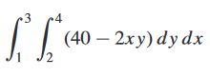  
7 |  |   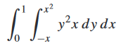
8 |  | 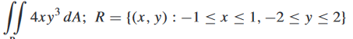  Find
9 |  | Find the gradient of f(x,y) = 5x²+y⁴ at the point (4,2).
10 |  | Let r(t) = t²i+e^{t}j – 2cosπtk. Find r’(t).
11 |  | Find a vector equation for the curve of intersection of the surfaces y = x² and z = y in terms of the parameter x = t.
12 |  | Find r’(t₀) where r(t) = 2sint i + 3cost j, t₀ = π/6.
13 |  | Find the gradient of the function f(x,y) = 5 sinx² + cos3y.
 |  | Section 3.Answer any 3. Each question carries 4 marks
14 |  | .
15 |  | 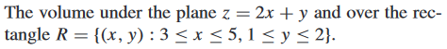  Find:
16 |  | 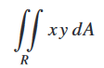
17 |  | Find the domain of r(t) and find the value of r(t₀) where r(t)= cost i – 3t j, t₀ = π.
18 |  | Find the directional derivative of f(x,y)= e^{xy} at (-2,0) in the direction of the unit vector that makes an angle of π/3 with the positive X-axis.
19 |  | A heat seeking particle is located at the point (2,3) on a flat metal plate whose temperature at a point (x,y) is T(x,y) = 10 – 8x² – 2y².
 |  | Section 4.Answer any 1. Each question carries 15 marks
20 | a | 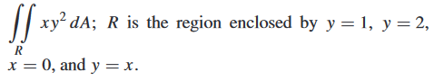  Evaluate
 | b | 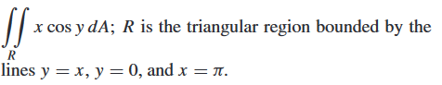  Evaluate
21 |  | Find a)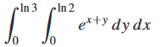 b)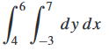 c)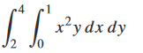
22 |  | - Find the directional derivative of f(x,y,z) = x²y – yz³ +z at the point (1,-2,0) in the direction of the vector a = 2i+ j – 2k.  - Let f(x,y) = x²e^{y}. Find the maximum value of a directional derivative at the point (-2,0) and find the unit vector in the direction in which the maximum value occurs.

